PROGRAMMING FUNDAMENTAL
(Assignment # 03)

(02 DEC 2025)
BY
AYESHA NOOR

ROLL# 25017119-013

CS-102(PROGRAMMING FUNDAMENTAL) BS CS 5th SEMESTER INDUCTION SECTION A
SUBMITTED TO MR.
Tasaddaq Latif
DEPARTMENT OF COMPUTER SCIENCE



Read the question statement carefully before answering it.
Question no.1:
Find the error in the following code. If no error then write the output .
#include <iostream>  using namespace std;  int main(){  int I,j;  for(I=1;I>7;I++)  cout<<I;  cout<<"End of Program";  return 7;  } | #include <iostream>  using namespace std;  int main() {  int num1 = 5, num2 = 10;  if (num1 < num2) {  cout << "num1 is smallest";  num1 = num2;  }  else {  cout << "num2 is smallest";  }  return 0;  }
#include<iostream>  using namespace std;  int main(){  int a=0, b=1;  a=b++;  cout<< a << b;  b=++a;  cout<< a << b;  return 0;  } | #include<iostream>  using namespace std;  int main()  {  cout<<"enter values";  int a,b,res;  cin>>a; cin>>b;  a=20; b=-10;  res = a+b;  cout<<"res = "<<res;  return 0;  }

Solutions:
1.
The loop condition I>7 is false from the start because I is initialized to 1, so the loop body never executes. The program will output "End of Program". The return statement return 7; is unusual but not an error; it indicates the program's termination status.

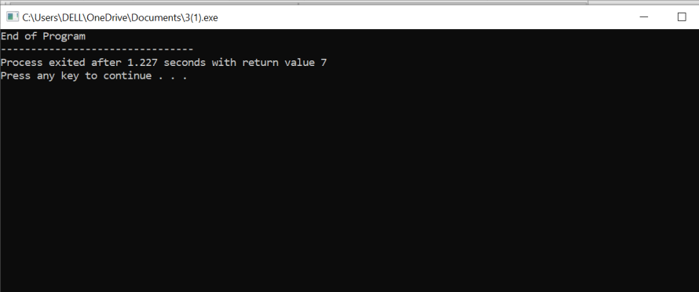

2.
This code has a syntax error because the else clause is not associated with the if statement due to the statement num1=num2; between them. The correct code should either remove or restructure this line to be part of the if or else block.

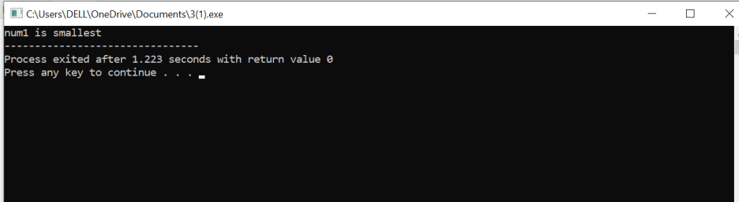
3.
Let's analyze the code step by step:
1. a = 0, b = 1
2. a = b++ means a = 1 and then b = 2, so a = 1, b = 2
3. cout << a << b outputs 12
4. b = ++a means a = 2 and then b = 2, so a = 2, b = 2
5. cout << a << b outputs 22
The output will be 1222.
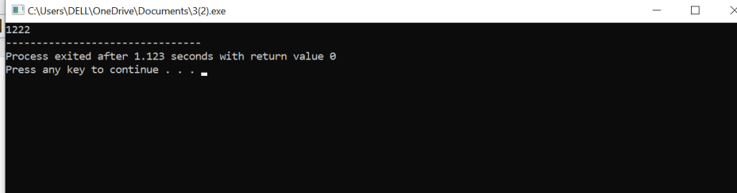

4.
The code has a syntax error in the line a+b=res;. It should be
res = a + b; because the left-hand side of an assignment must be a variable.
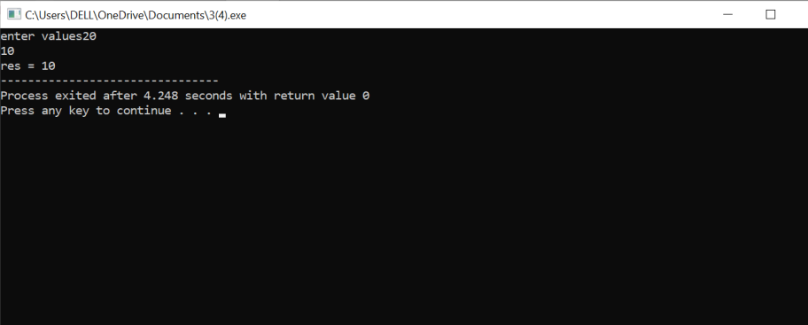

Question no.2:
Answer any two of the following?
- Header file
- Source code
- Comments
a) Header Files:
Header files contain predefined functions, classes, and declarations used in a program.
We include them using #include so we can use features like cout, cin, etc.
b) Source Code:
Source code is the human-readable code written by the programmer in a programming language.
It is compiled into machine code so the computer can execute it.
Question no.3:
Write a program that reads height in inches and displays the height in feet and inches.
#include<iostream>
using namespace std;
int main()
{
int totalInches, feet, inches;
cout<<"height in inches";
cin>>totalInches;
feet= totalInches/12;
inches=totalInches%12;
cout<<"feet"<< feet<<endl;
cout<<"inches"<<inches<<endl;
return 0;
}
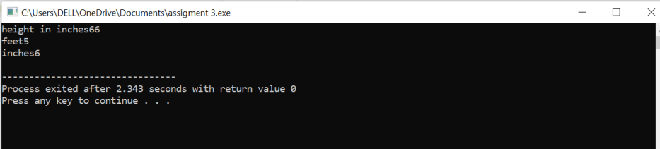

Question no.4:
Write a program that takes two numbers from the user and finds if the first number is a multiple of the second number.
#include<iostream>
using namespace std;
int main(){
int num1, num2;
cout << "Enter first number: ";
cin >> num1;
cout << "Enter second number: ";
cin >> num2;
if(num1 % num2 == 0)
cout << num1 << " is a multiple of " << num2 << endl;
else
cout << num1 << " is not a multiple of " << num2 << endl;
return 0;
}
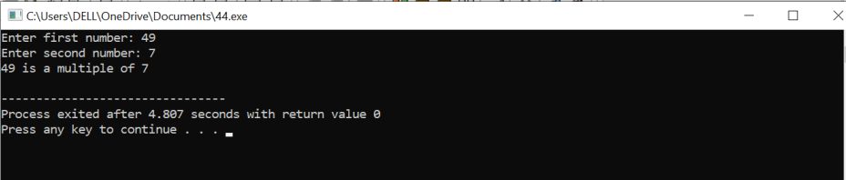

Question no.5:
Write a program that reads 10 numbers from the user and displays their sum, maximum, and minimum.

#include<iostream>
using namespace std;
int main(){
int numbers[10];
int sum = 0;
int maxNum, minNum;
cout << "Enter 10 numbers: ";
for(int i = 0; i < 10; i++){
cin >> numbers[i];
sum += numbers[i];
if(i == 0){
maxNum = minNum = numbers[i];
} else {
if(numbers[i] > maxNum) maxNum = numbers[i];
if(numbers[i] < minNum) minNum = numbers[i];
}
}
cout << "Sum: " << sum << endl;
cout << "Maximum: " << maxNum << endl;
cout << "Minimum: " << minNum << endl;
return 0;
}
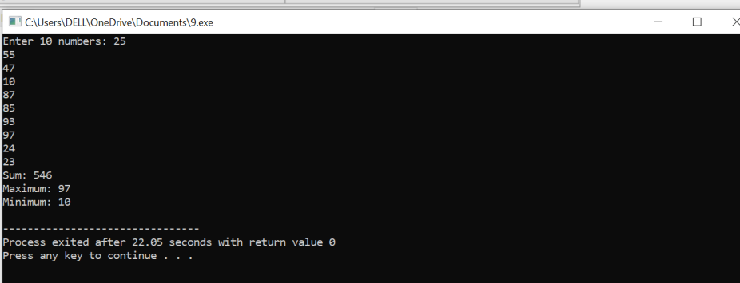

ASENDING ARRAY SORTING

#include <iostream>
using namespace std;

int main(){
int a[5]={5,4,3,2,1};

for(int i=0;i<5;i++){
int min=i;
for(int j=i+1;j<5;j++){
if(a[j]<a[min]) min=j;
}
int t=a[i];
a[i]=a[min];
a[min]=t;
}

for(int i=0;i<5;i++) cout<<a[i]<<" ";
}
